**DBT Module Exam–SEP PRN - 220940320077**

**Name : Pragati Dnyaneshwar Gaje Center : Kharghar**

- - - - - - - - - **- - - - - - - - - - - - - - - - - - - - -- - - - - - - - - - - - - - - - - - - - - - - - - - - - - - - - - - - - - - - - - - - - - - -**

**Question 1)**

**1. Create minimum 3 tables without any Key constraints (5)**

**Query:**

create table menu

(

item_no int,

cuisine varchar(15),

dish varchar (20),

cost float

);

create table orders

(

order_no int,

table_no int,

customer_name varchar(20),

waiter varchar(20),

item_no int,

order_desc varchar(30)

);

create table customers

(

customer_name varchar(20),

order_no int

); 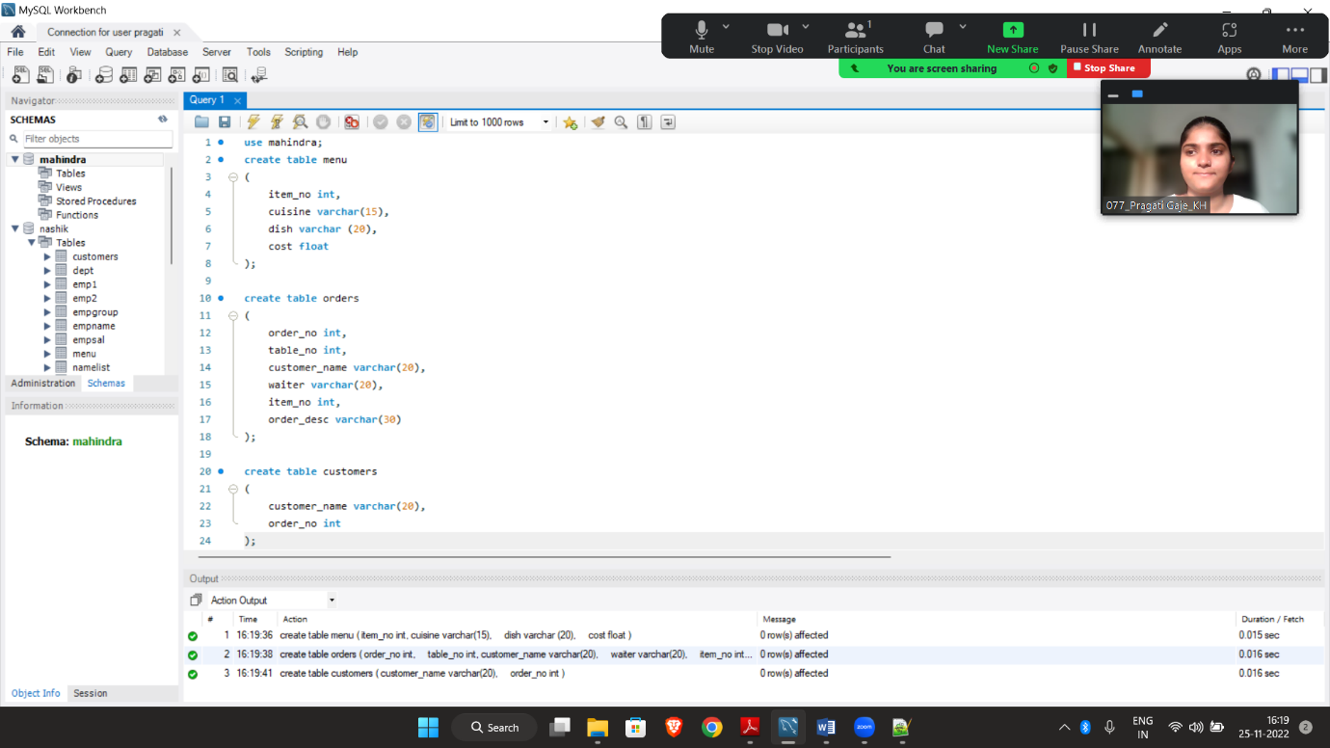

**2. a Add Primary Key to each table (2.5)**

**Query:**

alter table menu add primary key(item_no);

alter table orders add primary key(order_no);

alter table customers add primary key(customer_name);

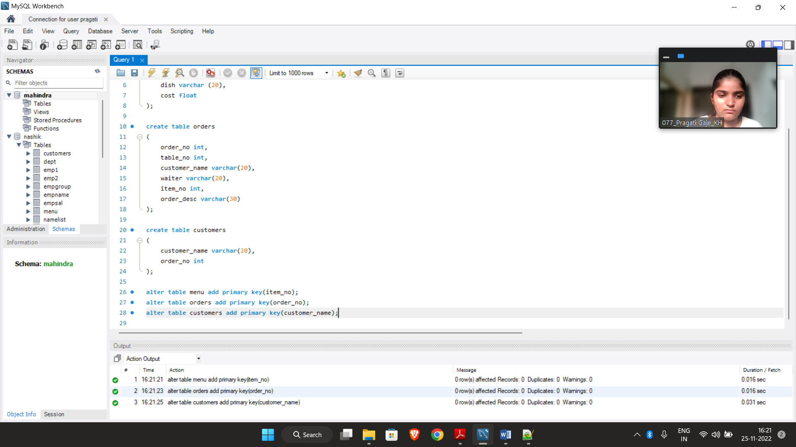

**2.b Insert minimum five records in each of the table (2.5)**

**Query:**

insert into menu values

(1, 'Maharashtrian', 'Misal Pav', 100),

(2, 'Maharashtrian', 'Pav Bhaji', 120),

(3, 'Maharashtrian', 'Puran Poli', 250),

(4, 'Chinese', 'Fried Rice', 120),

(5, 'Chinese', 'Schezwan Rice', 140),

(6, 'Chinese', 'Hakka Noodles', 140),

(7, 'Maharashtrian', 'Fish Thali', 500),

(8, 'Maharashtrian', 'Chicken Thali', 500);

insert into orders values

(001 , 5, 'Pooja', 'Ramu', '2 X Chicken Thali'),

(002 , 1, 'Pragati', 'Chotu', '2 X Misal Pav'),

(003 , 3, 'Nachiket', 'Bunty', '2 X Pav Bhaji'),

(004 , 4, 'Prachi', 'Chotu', '2 X Fish Thali'),

(005 , 6, 'Nikita', 'Chintu', '2 X Hakka Noodles');

insert into customers values

('Pooja', 001),

('Pragati', 002),

('Nachiket', 003),

('Prachi', 004),

('Nikita', 005);

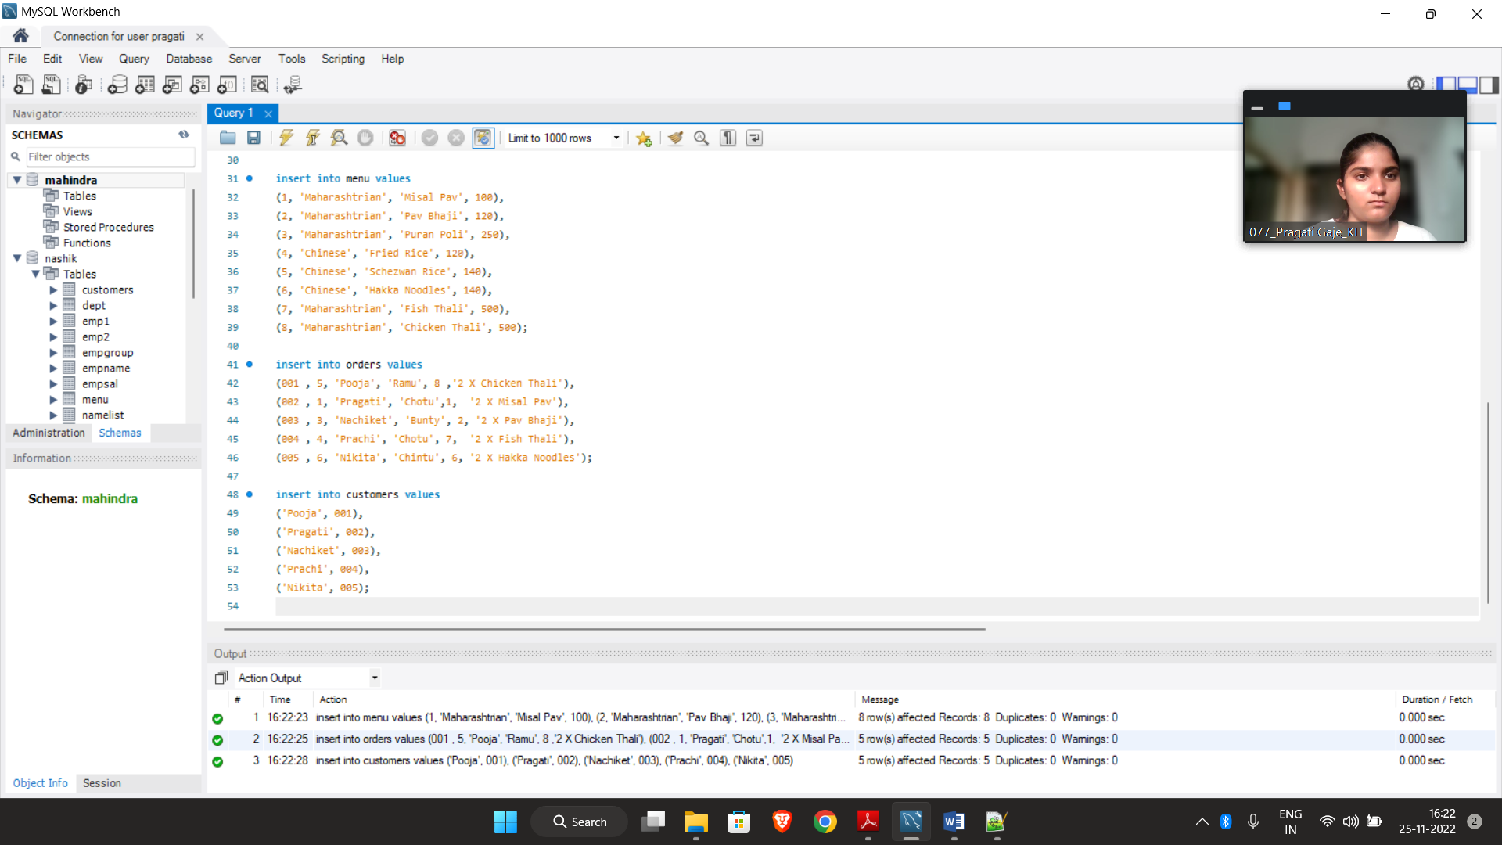

**3. Connect atleast 3 tables using Foreign Key (2)**

**Query:**

alter table orders add foreign key (customer_name) references customers(customer_name);

alter table customers add foreign key (order_no) references orders(order_no);

alter table orders add foreign key (item_no) references menu(item_no);

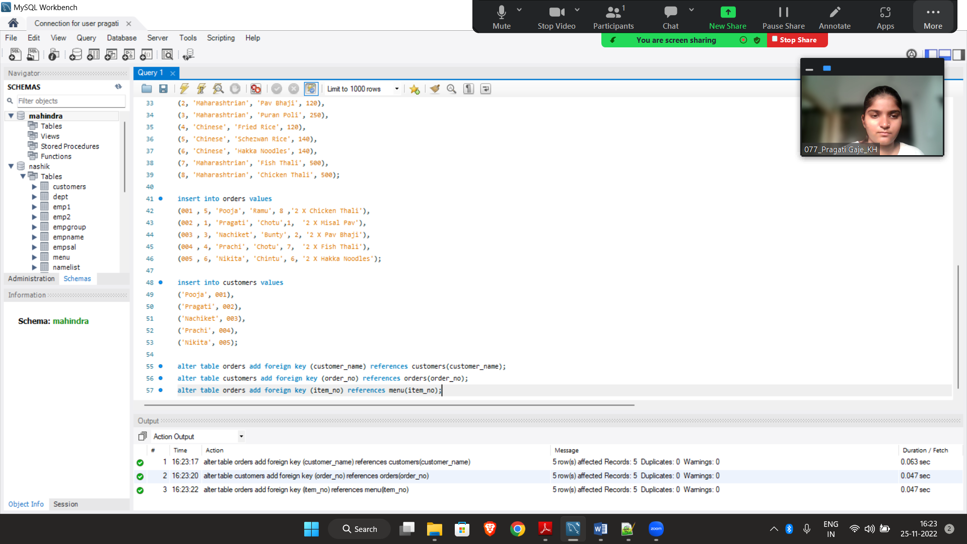

**4. Write an appropriate command to Use of Where with OR clause (2)**

**Query:**

select* from orders where waiter = 'Chotu' or 'Ramu';

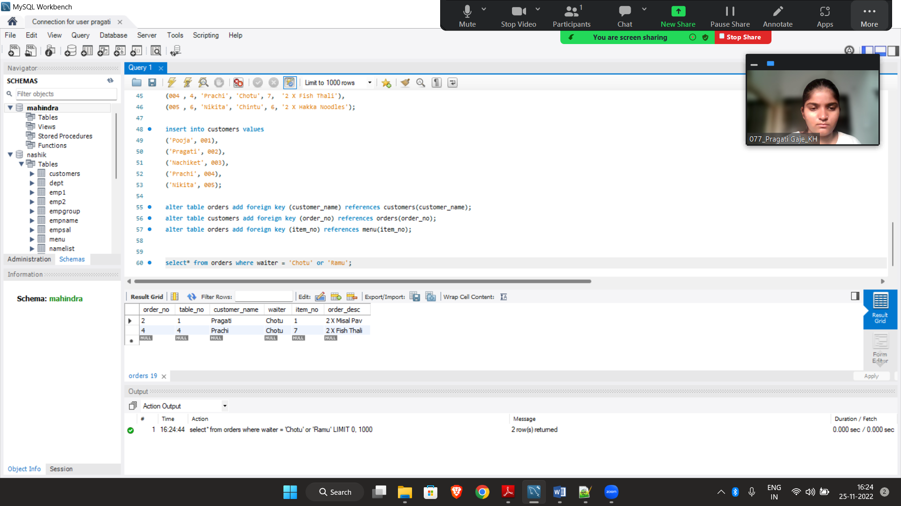

**5. Write a command to show first five records from any one table (2)**

**Query:**

select * from menu limit 5;

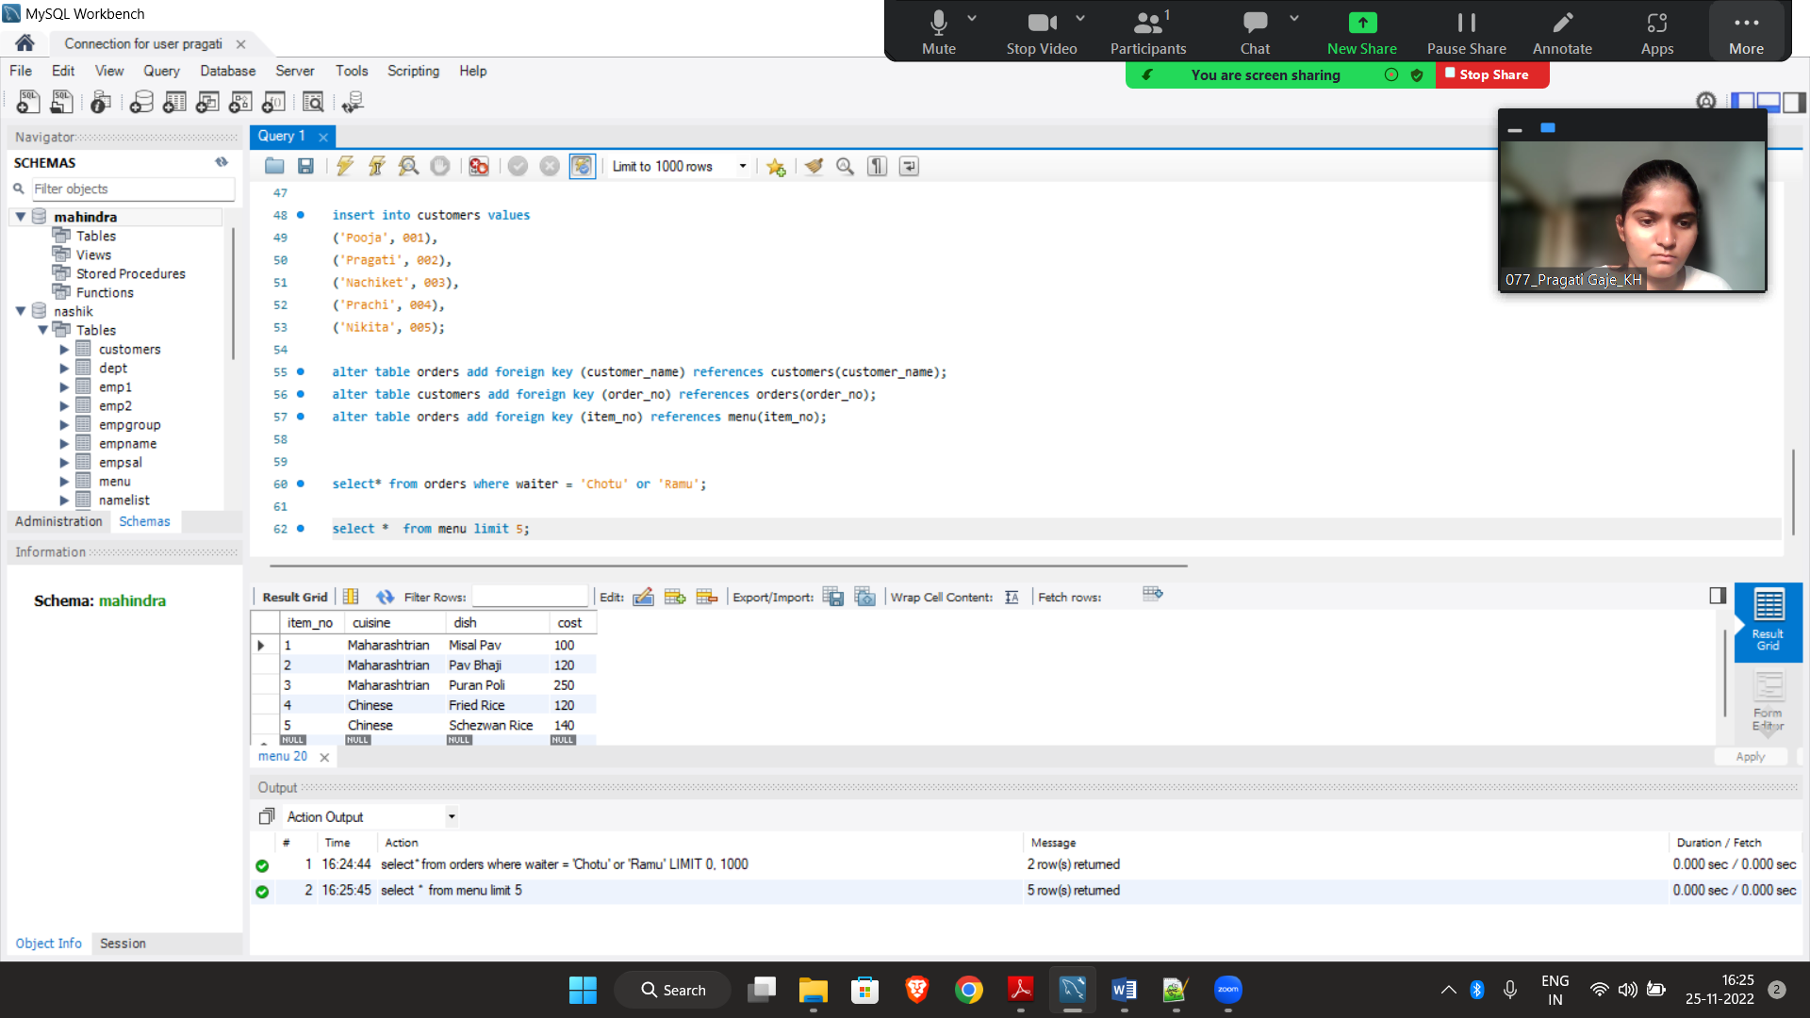

**6. Write a command for appropriate and logical use of Group By clause (2)**

**Query:**

select * from orders group by item_no;

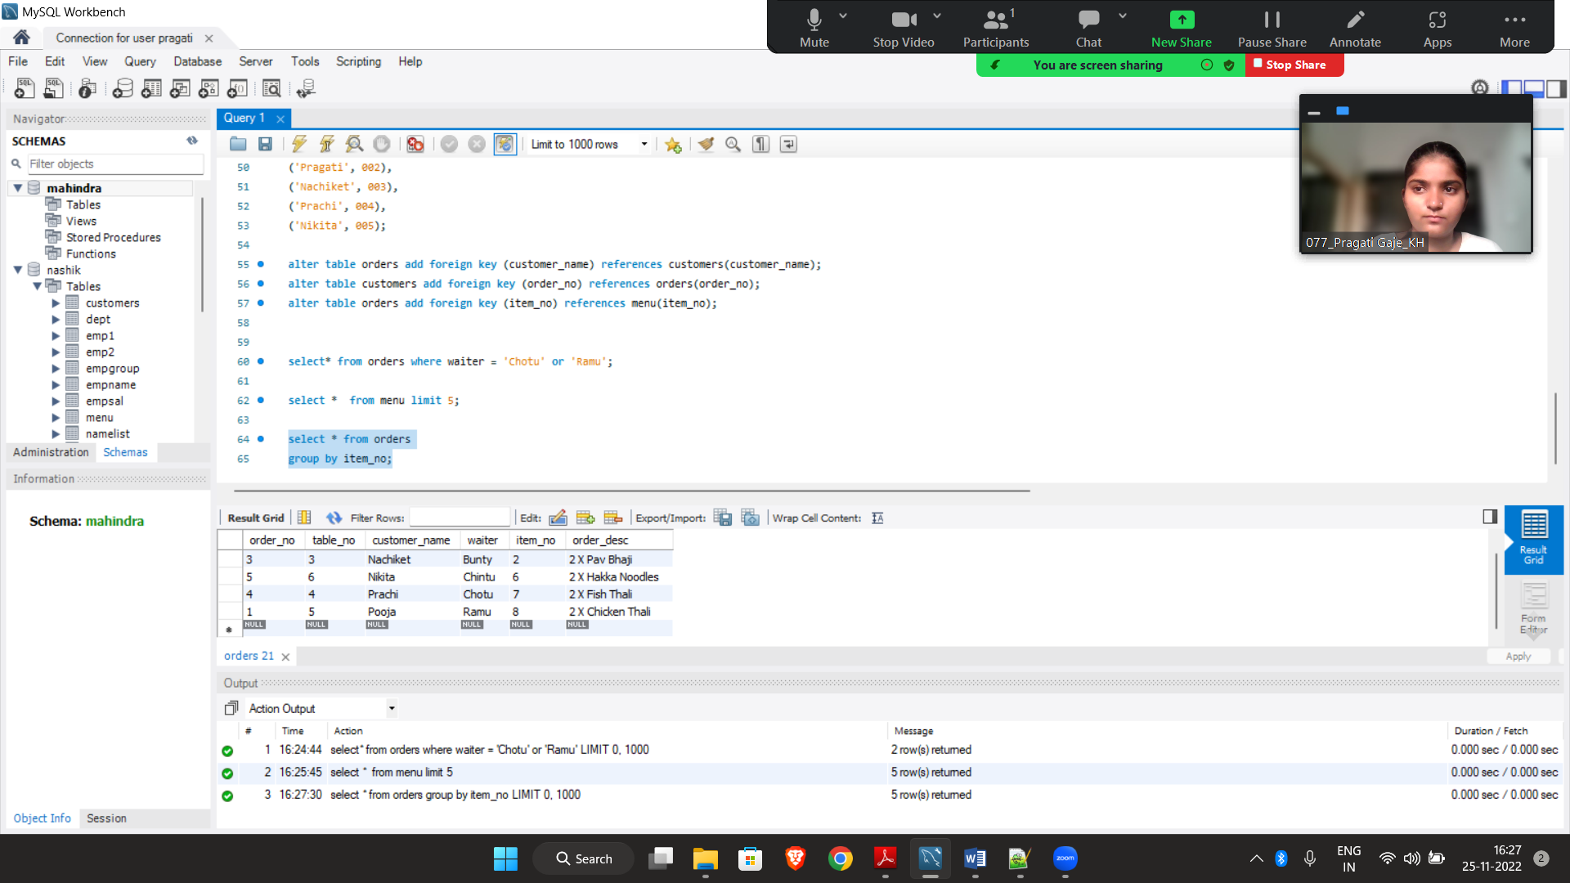

**7. Write a query to show the name of costliest Menu along with its cost (2)**

**Query:**

select dish , cost from menu

where cost=

(select max(cost) from menu);

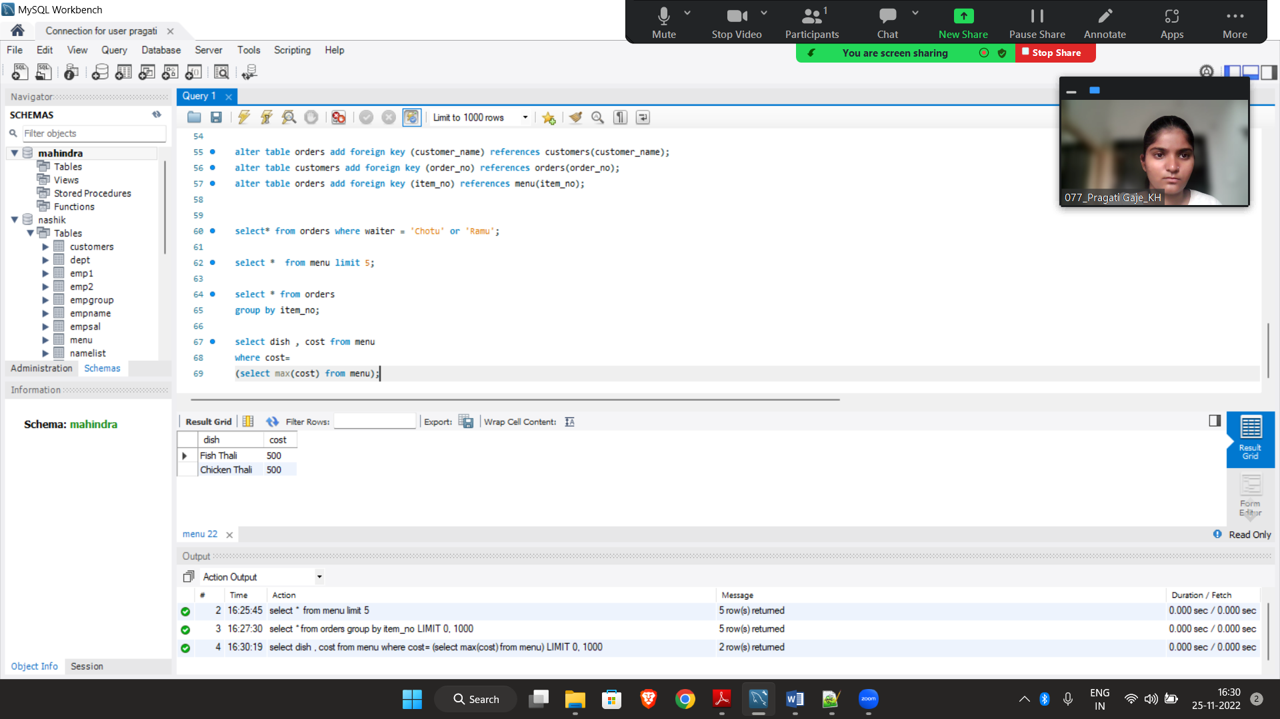

**8. Write a command to use LEFT JOIN (2)**

select * from orders left join customers on orders.order_no = customers.order_no;

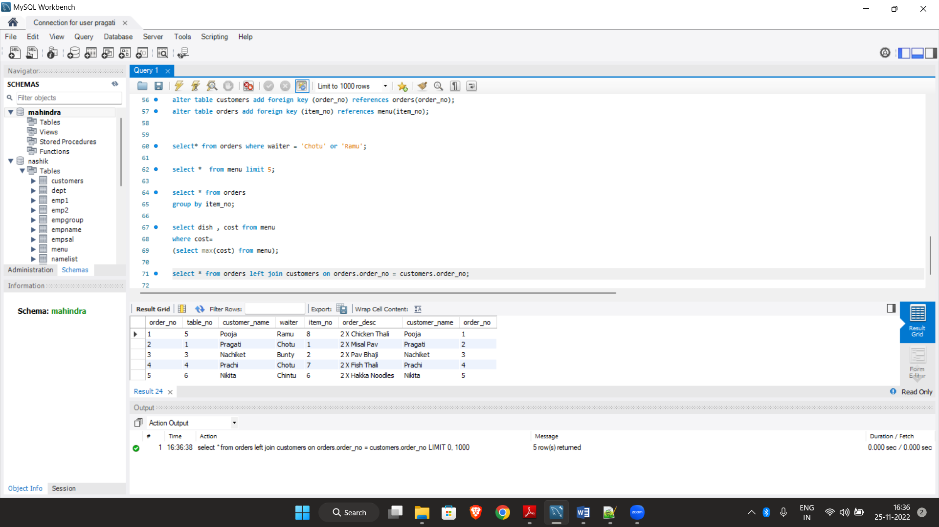

**9. Create the temporary table showing only menu of 'Chinese'. How to remove this table permnantly? (2)**

create table tempp as select * from menu where cuisine = 'Chinese';

select * from tempp;

drop table tempp;

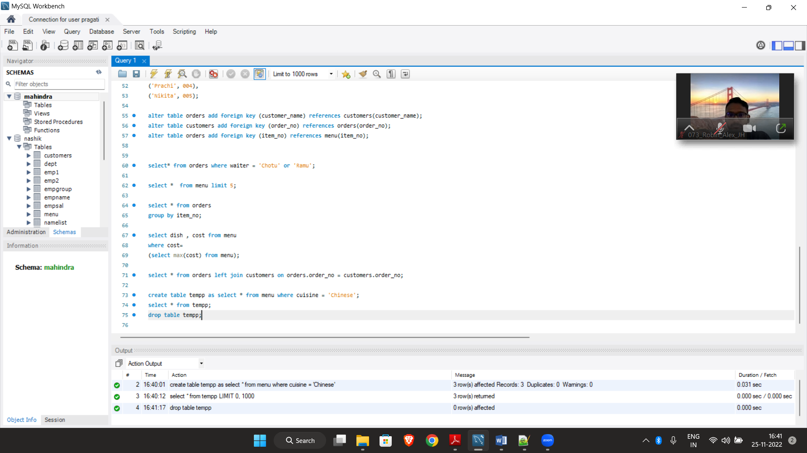

**12. Write a program to display first 5 even numbers using any one of the looping structure of MySQL (3)**

**Query:**

create table even

(no int);

delimiter #

create procedure printevenno()

begin

declare a int default 2;

repeat

insert into even values (a);

set a = a + 2;

until a > 10

end repeat;

end; #

call printevenno();

select * from even;

